Table of Contents

Project Team 2

Project Overview 3

Deliverables 7

Issues encountered 9

Presentation of Solution 10

UML 1(Jazmin) 10

UML 2(Lovu) 10

Design 10

Design Rationale 11

Pivotal Tracker 12

Priority 12

Epics 12

Releases 15

Burn Down Charts 16

Project Team

|  |  |  |  |
| --- | --- | --- | --- |
| Project Team Member | Role | Focus Area | Delivered Feature/Task |
| Jasmin Zaria  300710945 | Developer | Use case activity | Patient Assessment  Clinical Orders  Medical Impression & Diagnosis |
| Lovu Dhiraj Sharma-300721225 | Developer | UML and workflow process | Electronic Medical Records  Reports-generation and printing |
| Michael Giberson-300647274 | Scrum Master | Design and component specification | Activity and development progress monitoring of stories and task to be accomplish  Project documentation and collaboration task. |
| Sunny Chan 300736919 | Developer | Database design (ERD)  Database setup | User Access  Patient Appointment |
| Tram Do  300654255 | Developer | Class  GUI | Patient Registration  Creating Visit  Assigning Doctor |

No changes made on role and project delivery task assigned to team members.

Project Overview

Currently the health care industry’s hospital information systems are largely paper based. Paper based systems have been effectively deployed by the health care industry for decades. However, the system that once served the industry for many years started to show signs of strain and weakness due to higher demands. Reports released by Health Canada in 2009 express the concerns over the current system and state that healthcare expenditures could be slashed by $1Billion CAD by upgrading to a less paper based system (Industry Canada, 2009).

Besides being unable to effectively handle the increased demand on the system, current paper based hospital information systems have other detrimental short comings. Errors in medical record due to improper transcriptions or illegible writing have been known to cause medication mix ups. Incomplete and partial medical records often occur in paper based systems due to improper record keeping practices. The current systems lack validation, which is a crucial safeguard especially when dealing with administering medication and confirming the transfers of patient’s trough different wards in the hospital.

Input redundancies due to poor patient record maintenance and poor flow of information also lead to inefficiencies in the system. Due to these many issues with the current system patients are not receiving the best possible care. There are serious implications when dealing with providing health care to patients- where one error could be fatal.

These issues stress the need for an improved hospital information system. A new clinic information system (CIS) will be mutually beneficial to both the government and the patients. The government will experience significant cost savings and patients will enjoy safer, more efficient hospital care.

The new proposed system will increase operational efficiency and patient safety in healthcare service via a seamless information system that address information input redundancy, maintenance of patient records, fast turn-around time, and quality clinical administration of service.

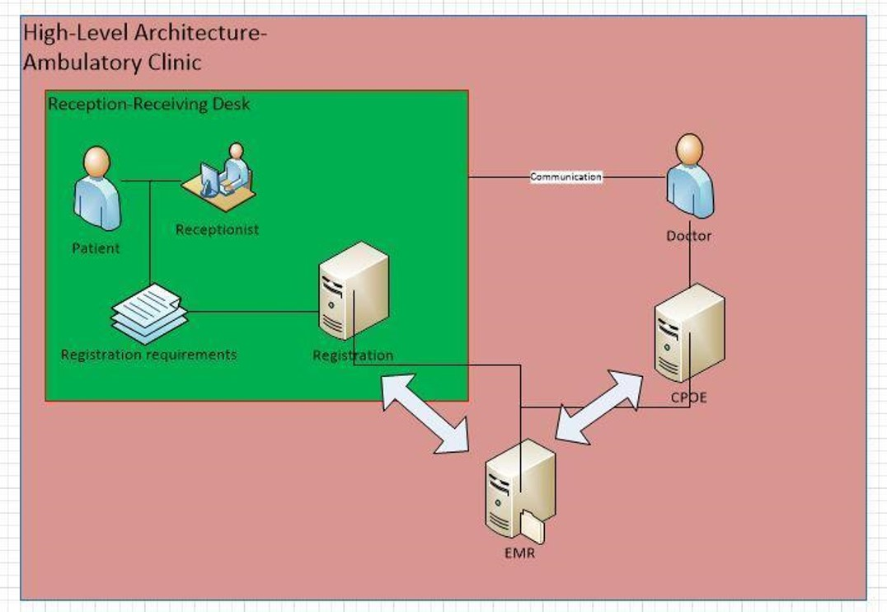

Figure 1: High Level Architecture

No change was noted on the solution developed, as illustrated in the high level diagram (Figure 1) Registration module captures patient demographics and assigning doctor. Information input during registration process flows to patient medical records which constitute the EMR.

CPOE, a clinical module is designed for doctors or clinicians’ in capturing patient health information. Health information collected during patient-doctor encounter and doctors’ clinical analysis of patient condition are translated into another composition part of EMR.

EMR in its totality composes of patients’ identity, health information, medical encounters, treatment, ordered test, clinical decisions and final diagnosis.

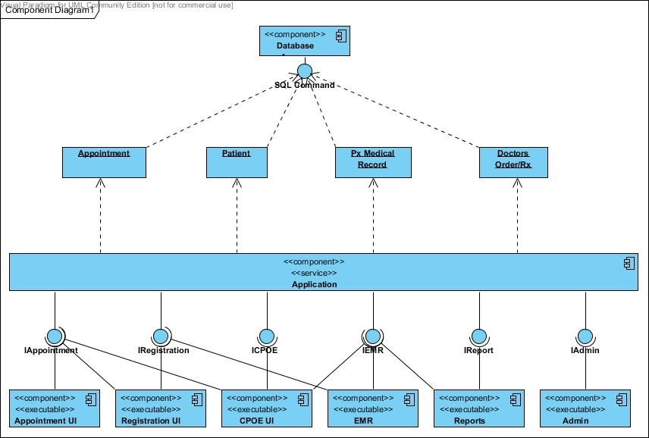

Figure 2: Component Diagram

## Deliverables

Modules and Features

1.   **Patient Appointment Module**

1.0  Patient request appointment for consultation through phone or personally through the clinic reception desk

1.1   Receptionist verifies schedule of doctors

1.1.1        Logs patient appointment request

2.   **Patient Registration Module**

1.0  Patient brings in referral form

1.0.1        Presents OHIP ID

1.1  Receptionist receives and verify referral and appointment

1.1.1        Verifies Patient No.

1.2  System search patient name and records

1.2.1        Confirms patient record

1.2.2        Updates patient demographics

1.2.3        Open visit

3.   **CPOE**

3.0  Physician receives patient in treatment/consultation room

3.0.1        Open patient medical record

3.0.2        Review past medical history (if available)

3.0.3        Enter Chief complaint and/or reason for consultation

3.0.4        Enter patient assessment

3.0.4.1  Vital signs

3.0.5        Creates clinical orders for the patient

3.0.5.1  Laboratory order

3.0.5.2  Radiology order

3.0.5.3  Medicine prescription

3.0.6        Enter clinical impression or summary

3.1  Enter final diagnosis

3.2  Create follow up appointment or referral

4.   **EMR/Reports**

4.0  System creates patient  Electronic Medical Record (EMR)

4.0.1        Maintain clinical records

4.0.2        Secure/Retrieves records

4.0.3        View Records

4.0.4 Prints record

## Issues encountered

1. **Database design, data type**

Issue are identified during the initial planning stage wherein serve as opportunity for improvement for the entire team. The developers responded to the need for resolution by going back to drawing table and discuss the issue and concerns. Issues like cardinality and relationship of entities surface during initial stage. It was corrected prior the development started.

1. **Activity Workflow**

Questions regarding activity work flow were observed during development stage. Clarification of role and responsibility of target user was the usual point of discussion.

1. **Unit Testing**

Unit testing was also noted during the development activity. Doing proper unit testing slows down the progress and velocity of the team. Status can’t be close unless unit testing is successfully carried out and pushed into the repository.

1. **Issue on version control and repository**

Collision of documents and merging a request in GitHub was also encountered. Proper way and scheduling was found to be a cause of this issue which at the later stage was improved and coordinated accordingly.

Presentation of Solution

## UML 1(Jazmin)

## UML 2(Lovu)

## Design

The Medical Information Management System project requires:

* CRU patient information
  + medical information (subsystem)
    - handled by Doctors
    - patient information should store based on CPOE (subsystem) standards
      * standards are set by Manager/Administrator
  + personal information (subsystem)
    - handled by Receptionist
  + CRUD patient appointment and doctor schedule (subsystem)
  + by Receptionist
  + and ties to the patient information module
* CRUD employees (subsystem)
  + manage doctors, nurse, receptionist
  + by Manager/Administrator
* *Environment that is secured (privacy of patient information).*
* *Flexible for different institution (not just Ontario).*

Project is being built on a Microsoft environment:

* Most common operating system.
* Most health-care institutions are already using Microsoft environment.

Thus,

* Coding in a Microsoft supported language (C#).
* Using a Microsoft SQL Database:
  + supported by Microsoft.
  + works in a Microsoft environment.
  + functionality for the database to be encrypted (to protect medical data, without having to write extra code to provide security).

is chosen over

* Java and Oracle/MySQL due to existing operating environment health-care institutions are already using MS SQL already.
* Web-based application due to how the health-care industry issues with privacy of patient information.

*To ensure privacy of patient information:

* all medical information is time stamped and linked to a doctor.
* Doctors are the only people able to access patient information.
* access log is created*

## Design Rationale

<Insert Database Diagram>

* A person could have multiple addresses, phone numbers, emails.
* A patient could have multiple insurances, allergies.
* A patient should have multiple EMR.
* A EMR could have multiple medication, laboratory, radiology, diagnosis.
* Medication, Laboratory, Radiology, Diagnosis and Allergies are *referenced* tables

**Eliminate redundancy:**

* patient and employee have redundant information in both tables is store as person

**Anomalies:**

* Doctor, manager, receptionist are separate tables to improve portability at the cost of efficiency.

## Pivotal Tracker

### Priority

1. Low complexity stories(input, demographical info)

Prioritization was formed with the consideration that particular story can easily be delivered by the developer. Story which will not entail large amount of time to develop and can be presented to project owner and have the consented approval that it pass the criteria and need of the owner.

1. Based on workflow process

Frontline activities are considered as one criterion in prioritizing story to build. Including story that shows output product like viewing medical records or generating reports.

### Epics

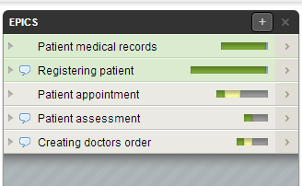

Figure 3: Epics

1. Appointment (figure 4)
2. Registration (figure 5)
3. Assessment (figure 6)
4. Doctor’s Order (figure 7)
5. Patient medical records/EMR (figure 8)

Epics where created on the basis of high level activity work flow of the user needs. It show the high level description of the project.

Instead of creating a complex story that could contain breakable smaller story, easy and testable user story was created. Story that can be easily carried out and submit to project owner for evaluation.

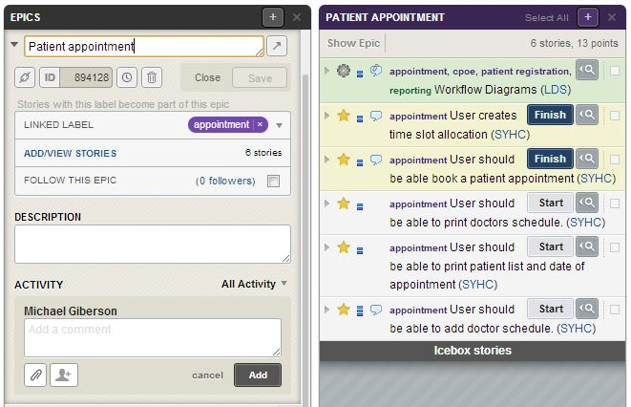

Figure 4: Patient Appointment

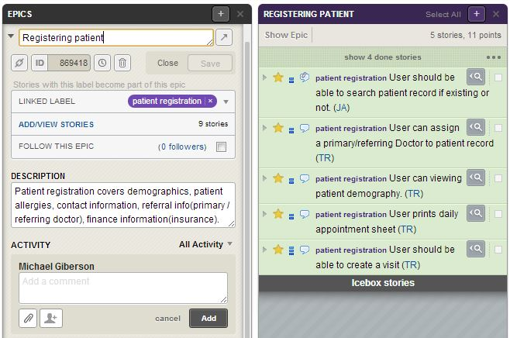

Figure 5: Patient Registration

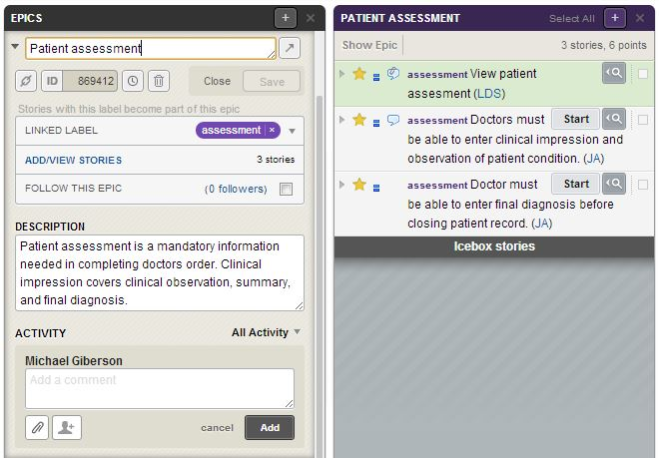

Figure 6: Patient Assessment

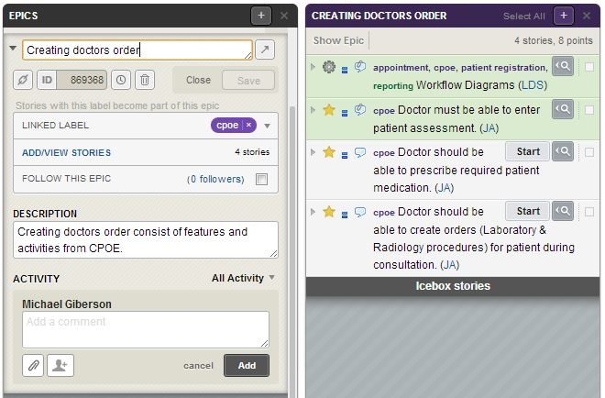

Figure 7: Clinical Order

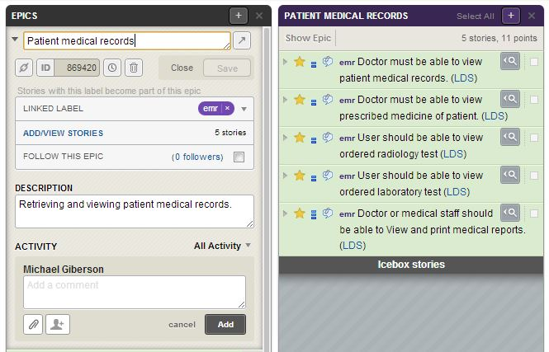

Figure 8: EMR

### Releases

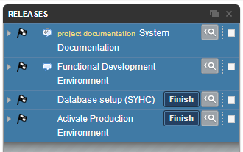

Figure 9: Releases

### Burn Down Charts

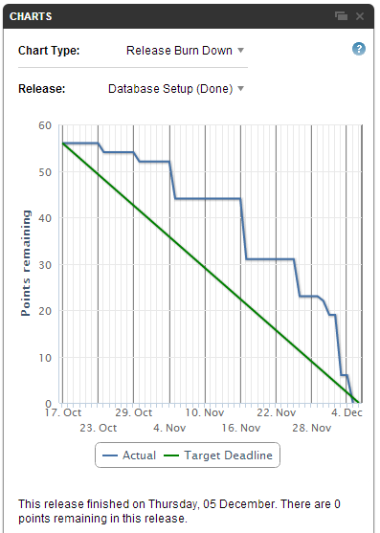

*Blue line identifies the true progress through the set release. Database set up target deadline is Dec.6th of 2013, as shown by the Green line in the chart. In this chart it shows that the actual work was delivered before the set deadline. Zero points remaining in was this release noted by Pivotal Tracker.*

Activate Production Environment

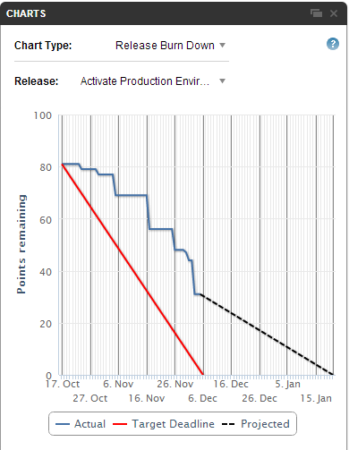

Figure 10: Activate Production Environment-Burn down Chart

*Blue line identifies the true progress through the set release. In our project the deadline set for the production is Dec.6th of 2013, as shown by the Red line in the chart. Considering the current velocity Giberson et.al has the point the chart was generated which is one day before the target deadline, approximately 30 points that needs to be delivered and close for production.*

Database Setup